Documentation

on

devops

(Part-01)

**DevOps Devops 7C’s**

* Fundamentals of DevOps
* 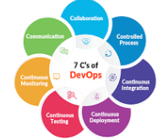Operating system
* Version Control
* Containerization
* Orchestration
* Infrastructure as code (IaC)
* Networking
* Security
* Monitoring
* Logging

**Principles of DevOps**

**DevOps**

DevOps means Development and Process. DevOps is the process of Software Development Process (SDLC). It is used for collaboration and Communication.

**Operating System**

Operating System means communication between the user and hardware

* System Oriented Operating System
* Server Oriented Operating System

**Version Control**

Version control is also known as source control. It is a system that tracks the changes in a file overtime.